

|  |  |  |
| --- | --- | --- |
| Mathematics Department | |  |
| Course: A1MAA | |
| Topic Title: Test 3 | |
| Student Name:_____________________________________ | Date: ____________ | | |
| Special Instructions: Formula Sheet Allowed | Time Allowed: 45 minutes | | |
|  | Marks: / 42 | | |

**Question 1. [2,2,1,3,:8 marks]**

The dimensions of triangles A, B and C are shown below (diagram not to scale).



(a) Use Pythagoras' Theorem to show that triangle A is right-angled.

(b) Only one of triangles B or C is similar to triangle A. State which triangle is similar to triangle A and justify your answer.

(c) Show that the area of triangle A is 6 cm2.

(d) Triangle D has an area of 600 cm2 and is similar to triangle A. Determine the lengths of all the sides

**Question 2. (5, 5 : 10 marks)**

The diagrams below show two possible plans for a garden outside a new medical centre.

Diagram 1 Diagram 2

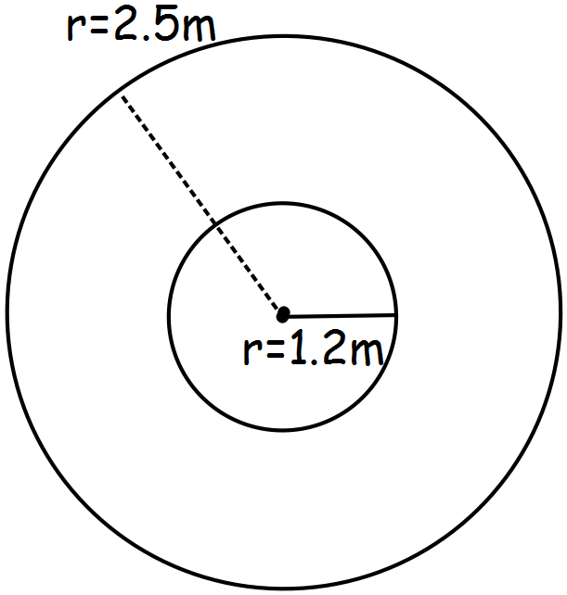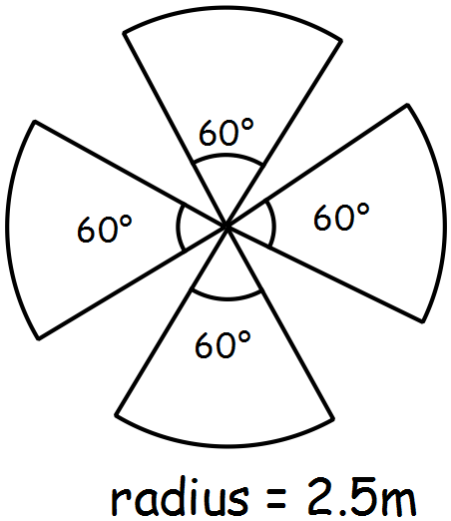

1. A low garden fence around each section of the garden will cost $15 per metre. Calculate the cost of

fencing the two gardens and decide the most cost effective design.



1. If fertilizer costs $5.50 per square meter calculate the cost of keeping each garden healthy, which will be cheaper?

**Question 3. [2,2,1,3 : 8 marks]**

The sketch below shows a solid wooden sphere with a radius of 7.5 cm.



(a) Calculate

(i) the volume of the sphere.

(ii) the total surface area of the sphere.

(b) The wooden sphere is sliced in half to create two hemispheres. Calculate

(i) the volume of one of the hemispheres.

(ii) the total surface area of one of the hemispheres.

**Question 4. (1, 3, 5:9 marks)**

A rectangular prism measuring 30cm by 40 cm by 8cm has a circular hole bored through its centre from one side to the other as shown below.

**

(a) What was the volume of the rectangular prism before the circular hole was bored?

After the circular hole was bored, the volume of the remaining prism was half of the original volume.

(b) Show with calculations that the radius of the circular hole must be 13.82cm, correct to 2 decimal places.

(c) Determine the total surface area of the solid that remains after the circular hole is bored as shown above, correct to the nearest cm2.

**Question 5. [3,2 : 5 marks]**

In the diagram below, CD = 2.8cm, AD = 11.2cm and BC = 7cm.

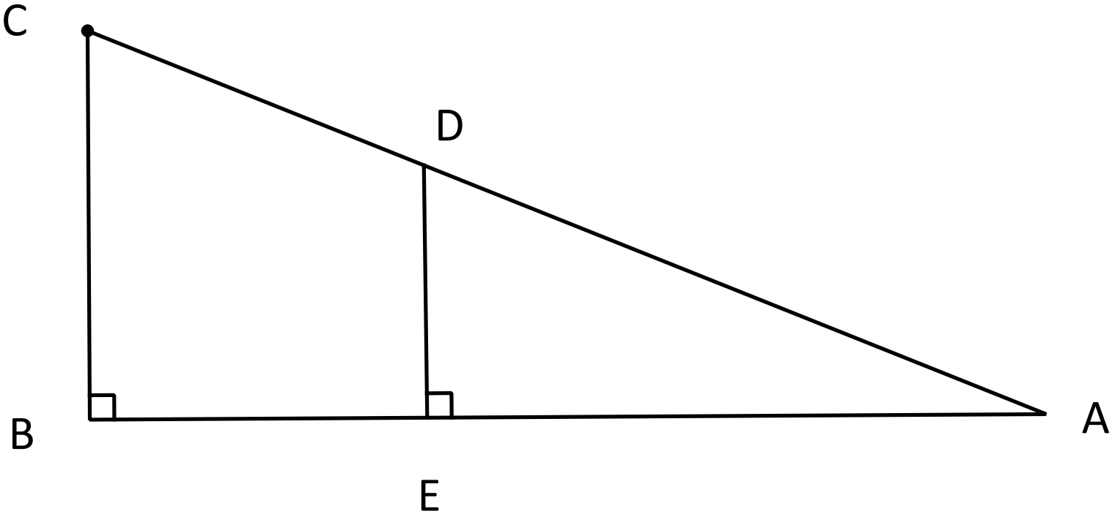

a) Prove $∆ABC \sim ∆AED$

b) Determine the length of DE

**Question 6 [2 marks]**

Calculate the volume of a triangular pyramid that is constructed inside a triangular prism if the volume of the prism is 51cm3.